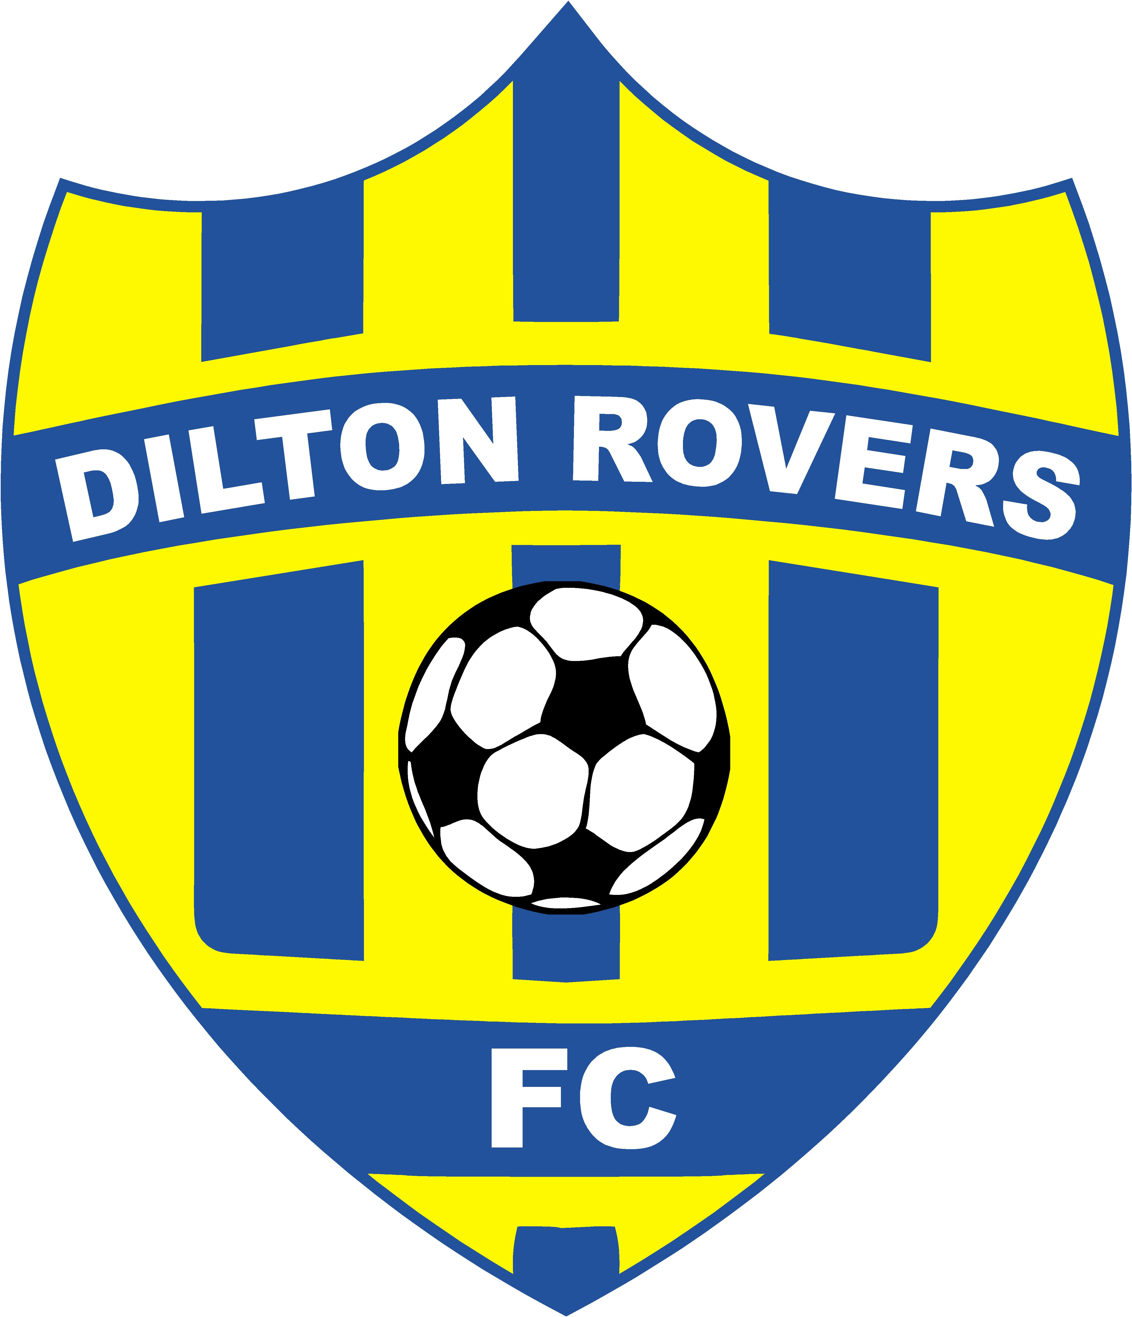 Dilton Rovers FC
Covid-19 Control Measures
Carried out by | Rich Hudd-Team Manager  Ian Philps-Club Welfare Officer
Date Carried out
Review Date
Location | Dilton Playing Fields
Potential Hazard | Transmission of COVID-19

Activity | CONTROL MEASURES IN PLACE | RISK FACTOR | FURTHER CONTROL MEASURES
Arrival | - Team members will be met by the designated Social Distancing coordinator (SDC) and directed to their training area and coach for the training session.  - Upon arrival the SDC will fill in a register of who is present for track and trace purposes | Low
Hand Hygiene | Hand gel will be provided at the beginning and end of the training session. | Low | Hand gel will be available via the SDC at any point during training.
Equipment | - All training equipment will be disinfected by the coaches before the start and at the end of every training session.  - The players will train with one ball per person, with the exception of passing drills and set pieces ie corners / free kicks | Low | The SDC will have a bottle of spray disinfectant to disinfect any equipment that has come into contact with skin or bodily fluids
Training Session | - All training sessions will be planned and executed following the FA Guidance on permitted Grassroots football activity during COVID-19-1 June 2020  - Training will be conducted in groups of no more than 6 (including the coach)  - All training will be of a non contact nature, during which the players will be expected to maintain a strict 2m distance from other players and the coach.  - When not taking part in a specific training event or waiting their turn, players will be assigned an individual area marked with cones at least 2m from the coach or other team members | Medium | The SDC will monitor the training groups to ensure the 2m social distancing rules are adhered to, any player constantly of flagrantly disregarding the2m rule will be asked to sit out for a period of time
Toilet Facilities | - The toilet facilities will be cleaned before every training session.  - The toilet facilities will be for the use of players only  - The toilet facilities will remain locked until needed by a player | Low | The SDC will control the keys for the toilet, he will unlock the door, wait outside until the player has finished and then disinfect the toilet and lock it again
Drinking Water | Players will still require drinking water; bottles will need to be clearly labelled with their names to avoid confusion, and kept on their person. | Low
Parents | Parents are requested to maintain social distancing as per government guidelines | Low

Dilton Rovers as a club will be closely monitoring the infection rate (R rate) and following both guidance from the FA and government with regards to how long we can stay open and what activities we are able to undertake.
We will review this assessment every 2 weeks.
These measures are a temporary addition to the safeguarding policy; all previous safeguarding measures remain unchanged.
If you have any concerns please don’t hesitate to contact a member of the welfare or coaching team.

