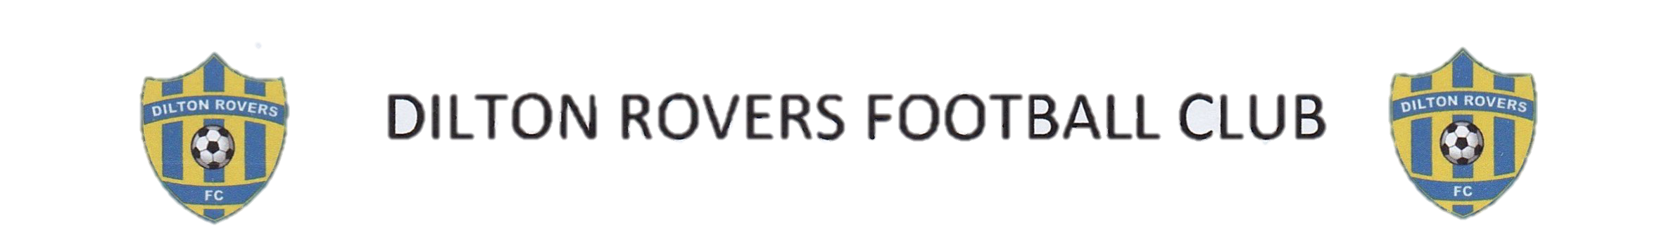

DILTON ROVERS FOOTBALL CLUB CONSTITUTION
- Name
The club will be called Dilton Rovers Football Club and will be affiliated to Wiltshire County FA
- Aims and objectives
The aims and objectives of the club will be:
- To offer inclusive coaching and competitive opportunities in Football for all age groups
- To promote the sport of Football
- To ensure a duty of care to all members of the club
- To provide all its services in a way that is fair to everyone
- To ensure that all present and future members receive fair and equal treatment
- Membership
Membership should consist of Official Role Committee Members and General Committee members voted on by the current committee.
All members will be subject to the regulations of the constitution and by joining the club will be deemed to accept these regulations and codes of conduct that the club has adopted and the policies and rules of Football League.
- Membership fees
Membership fees will be set annually and determined at the Annual General Meeting.
Fees will be paid by annual registration fee and monthly subscription
- Official Role Committee Members
The officers of the club will be:
- Chair
- Vice Chair
- Secretary
- Treasurer
- Club Welfare Officer

- Committee
The club will be managed through the Management Committee consisting of Official Role Committee Members and General Committee Members. Only these posts will have the right to vote at meetings.
The Management Committee will be convened by any Official Role Committee member of the club and held no less than eight times per year.
The Management Committee will be responsible for adopting new policy, codes of conduct and rules that affect the organisation of the club.
The Management Committee will be responsible for disciplinary hearings of members who infringe the club rules/regulations/constitution. The Management Committee will be responsible for taking any action of suspension or discipline following such hearings.
- Finance
All club monies will be banked in an account held in the name of the club.
The Club Treasurer will be responsible for the finances of the club.
The financial year of the club will end on: 31 May
An report of accounts will be presented by the Treasurer at the Annual General Meeting.
Any cheques drawn against club funds should hold the signatures of the Treasurer plus one other authorised signatory.
- Annual general meetings
Notice of the Annual General Meeting (AGM) will be given by an Official Role Committee Member. Not less than 14 clear days’ notice to be given to all members.
The AGM will receive a report from officers of the Management Committee and a report of accounts.
The Management Committee has the right to call Extraordinary General Meetings (EGMs) outside the AGM. Procedures for EGMs will be the same as for the AGM.
- Discipline and appeals
All complaints regarding the behaviour of members should be submitted in writing to the Chairperson.
The Management Committee will meet to hear complaints within 14 days of a complaint being lodged. The committee has the power to take appropriate disciplinary action including the termination of membership.
The outcome of a disciplinary hearing should be notified in writing to the person who lodged the complaint and the member against whom the complaint was made within 14 days of the hearing.
There will be the right of appeal to the Management Committee following disciplinary action being announced. The committee should consider the appeal within 21 days of the Secretary receiving the appeal.
- Dissolution
A resolution to dissolve the club can only be passed at an AGM or EGM through a majority vote of the membership.
In the event of dissolution, any assets of the club that remain will become the property of the Football League.
- Amendments to the constitution
The constitution will only be changed through agreement by majority vote at an AGM or EGM

Declaration
Dilton Rovers Football Club hereby adopts and accepts this constitution as a current operating guide regulating the actions of members.

